**Skeletal muscle involvement in patients with truncations of titin and familial dilated cardiomyopathy**

Sofie Vinther Skriver1, BSc*; Bjørg Krett1, MD*; Nanna Scharf Poulsen1, MD; Thomas Krag1, PhD; Helle Rudkjær Walas1; Alex Hørby Christensen2,3,4, MD, PhD; Henning Bundgaard2,4, MD, DMSc; John Vissing1,4, MD, DMSc; Christoffer Rasmus Vissing2, MD, PhD

* shared first authorship/contributed equally

1 Copenhagen Neuromuscular Center, Department of Neurology, Copenhagen University Hospital, Rigshospitalet, Copenhagen, Denmark.

2 Department of Cardiology, Copenhagen University Hospital, Rigshospitalet, Copenhagen, Denmark.

3 Department of Cardiology, Copenhagen University Hospital, Herlev-Gentofte Hospital, Copenhagen, Denmark.

4 Department of Clinical Medicine, University of Copenhagen, Copenhagen, Denmark.

**Funding:** The AP Møller Foundation (HB), The Research Foundations at Rigshospitalet and at The Capital Region of Denmark (CV and HB), The Independent Research Fund Denmark (0134-00363B, AHC), The Novo Nordisk Foundation Denmark (NNF20OC0065799, AHC), The Innovation Fund Denmark (HB) and NordForsk (through the funding to PM Heart (90580, HB)) supported this study.

**Disclosure statement:** None of the authors have conflicts of interest related to the current study.

**Running title:** Skeletal muscle phenotype in TTNtv

**Word count**: 4,984 words (5000 allowed) **Figures and tables:** 6

**Corresponding author:**

Christoffer Rasmus Vissing, MD: [christoffer.rasmus.vissing@regionh.dk](mailto:christoffer.rasmus.vissing@regionh.dk)

The Capital Region’s Unit for Inherited Cardiac Diseases, Blegdamsvej 9,

Rigshospitalet, Copenhagen University Hospital, 2100-DK, Copenhagen, Denmark

**Twitter handles:** @ulvedreng (CRV)

**Abstract**

**Background:** Variants in *TTN* are associated with dilated cardiomyopathy (DCM) and skeletal myopathy. However, the skeletal muscle phenotype in individuals carrying heterozygous truncating *TTN* variants (TTNtv), the leading cause of DCM, is understudied.

**Objectives:** Assess the skeletal muscle phenotype associated with TTNtv.

**Methods:** Participants with TTNtv were included in a cross-sectional study.Skeletal muscle fat fraction was evaluated by magnetic resonance imaging (compared against healthy controls and controls with non-TTNtv DCM). Muscle strength was evaluated by dynamometry and muscle biopsies were analyzed.

**Results:** Twenty-five TTNtv-participants (11 women, age 51±15 years, left ventricular ejection fraction 45±10%) were included (19 had DCM). Compared to healthy controls (n=25), fat fraction was higher in calf- (12.5% vs 9.9%, p=0.013), thigh- (12.2% vs 9.3%, p=0.004) and paraspinal muscles (18.8% vs 13.9%, p=0.008) of TTNtv-participants. Linear mixed modelling, found higher fat fractions in TTNtv participants compared to healthy controls (2.5% [CI: 1.4-3.7], p<0.001) and controls with non-TTNtv genetic DCM (n=7; 1.5% [CI: 0.2-2.8], p=0.025). Muscle strength was within 1 SD of normal values. Biopsies from 21 participants found myopathic features in 13 (62%), including central nuclei. Electron microscopy showed well-ordered Z-lines and T-tubuli but uneven and discontinuous M-lines and excessive glycogen depositions flanked by autophagosomes, lysosomes, and abnormal mitochondria with mitophagy.

**Conclusion:** Mild, skeletal muscle involvement is prevalent in patients with TTNtv and is characterized by an increased muscle fat fraction, and excessive accumulation of glycogen, possibly due to reduced autophagic flux. This emphasizes the need for specialized diagnostic work-up in patients with TTNtv displaying signs of muscle involvement.

**Keywords:** Inherited cardiomyopathies; genotype/phenotype; TTNtv

**Abbreviations list**

BMI = body-mass index

DCM = dilated cardiomyopathy

EF = ejection fraction

HNDC = hypokinetic non-dilated cardiomyopathy

LV = left ventricular

NT-proBNP = N-terminal pro-hormone B-type natriuretic peptide

NYHA = New York Heart Association

TEM = transmission electron microscopy

TTNtv = truncating titin variants

**INTRODUCTION**

Genetic variants leading to truncations of titin (TTNtv) represent the most common cause of familial dilated cardiomyopathy (DCM) 1–4. DCM-TTNtv is an autosomal dominant disease, with varying age-dependent penetrance, a high rate of cardiac arrhythmias, and a phenotype with a high degree of reversibility4, 5. Recessive missense (and rarely truncating) variants in the C-terminal of *TTN* can cause limb-girdle muscular dystrophy type 2J, distal tibial muscular dystrophy, congenital titinopathy and multi mini-core disease 6–8. Furthermore, dominant missense variants in exon 344 and 364 are associated with late-onset autosomal dominant tibial muscular dystrophy 9 and hereditary myopathy with early respiratory failure 10. Clinical features of these myopathies vary, but include progressive axial and limb weakness, loss of ambulation, and in some instances joint contractures. They can present at any age from infancy to late in life 6, 11. While genetic variants in *TTN* have been linked to a wide range of myopathies, the presence and degree of muscle involvement in individuals with familial DCM caused by heterozygous TTNtv have not been investigated. Prior studies in patients with other myopathies have found co-involvement of skeletal and cardiac muscles to be common 12–17 and a previous study investigating the health records of patients with TTNtv found clinical indications of co-involvement of skeletal and heart muscle in a subset of families 18. Based on this, we hypothesized that TTNtv leading to sarcomere insufficiency 19 and reduced function of cardiac muscle could lead to similar molecular and functional alterations of skeletal muscle. Reduced exercise capacity, fatigue and sarcopenia are frequently observed and reported by patients with DCM, and heart failure in general, and is associated with adverse outcomes 20–22. However, these features are often considered as secondary to cardiac affection, and are not investigated in more detail. As a result, there is potentially an unmet need to better characterize the muscle phenotype in these patients. This study sought to assess the presence and degree of skeletal muscle involvement in patients with TTNtv, identify underlying disease mechanisms, and describe factors associated with more severe muscle involvement.

**METHODS**

**Design and subjects**

The study was a cross-sectional study of patients with TTNtv. Trial participants were recruited from the Capital Region’s Unit for Inherited Cardiac disorders, Copenhagen University Hospital, a tertiary referral site providing diagnostic work-up, outpatient care, and family screening of patients with DCM. To be included, patients had to be between 18 and 80 years of age, carry a likely pathogenic/pathogenic truncating variant in *TTN*, as assessed by criteria of the American College of Medical Genetics 23, in an exon expressed in both heart and skeletal muscle 2, 24, 25. Subjects had to be diagnosed with DCM, hypokinetic non-dilated cardiomyopathy (HNDC), or be a genotype-positive first-degree relative to a DCM patient. Exclusion criteria included significant claustrophobia, inability to give informed consent, known myopathy, or presence of an implanted cardioverter-defibrillator or cardiac resynchronization therapy device.

To quantify the skeletal muscle phenotype as determined by fat replacement of skeletal muscle tissue on magnetic resonance imaging, healthy participants, matched for age, sex, and body mass index (BMI), were included in a ratio of 1:1. In addition, to assess for the effect of heart failure on fat replacement of skeletal muscle, we included patients with DCM caused by variants in *RBM20*, *DSP* and *MYBPC3*, encoding proteins not expressed in skeletal muscle (matched on LV ejection fraction). Participants were not recruited based on whether they had previously reported symptoms from skeletal muscle.

**Magnetic resonance imaging**

Investigations were performed on a 3.0 T MAGNETOM Verio scanner (Siemens AG, Erlangen, Germany). Three-planed localizers were acquired from neck to ankle, followed by T1-weighted and 2-point Dixon scans performed at six positions see **Figure 1**. For acquisition parameters see Supplementary methods S1.

Muscle cross-sectional areas and quantitative fat fraction analysis were calculated from the lower posterior border of C6, the lower posterior border of TH12, the lower posterior border of L4, the lower anterior border of S2, the midpoint of the thigh, and at the thickest point of the calf one-third of the distance from the knee to the ankle. Individual muscles or muscle groups were manually traced by authors SVS (in leg muscles) and BK (in back muscles) using the Horos medical image viewer software v2.4.1 (Horosproject.org, Annapolis, MD USA). All tracings were readjusted by NSP. The assessors analyzed images from both patients and healthy matched controls and were blinded to group assignement.

**Skeletal muscle biopsies**

Skeletal muscle biopsies were harvested from the vastus lateralis muscle. Biopsies underwent hematoxylin, trichrome, SDH and MHC I and II staining (supplementary methods **S1**). Based on light microscopy findings, eight samples were investigated by transmission electron microscopy (TEM) to assess sarcomere morphology and to visualize the myocyte ultra-structure. TEM samples were handled and investigated using a protocol previously described 26. Briefly, a piece of fresh muscle  was perfused with 2% electron microscopy grade glutaraldehyde in 0.05 M phosphate buffer. After post-fixation and staining, the biopsy was embedded in Epon and sectioned both at a transversely and longitudinal orientation. Sections were visualized in a CM100 transmission electron microscope (Philips, Amsterdam, Netherlands) fitted with a 4Mpixel Veleta camera (Olympus Soft Imaging Solutions GmbH, Munster, Germany).

**Muscle function**

Maximal isometric muscle strength was assessed across the hip, knee, and ankle joints with a handheld dynamometer in a make-test. Results from muscle dynamometry were compared to reference values for age and sex 27. Physical activity levels in patients were investigated using the International Physical Activity Questionnaire 28.

**Cardiac investigations**

Cardiac assessments included standard transthoracic echocardiography to assess cardiac function and morphology and analysis of blood for cardiac biomarkers, including N-terminal pro-hormone B-type natriuretic peptide (NT-proBNP) and cardiac tropnonins, and creatine kinase and myoglobin. In addition, we collected historical data on left ventricular ejection fraction (LVEF) and cavity dimension from examinations performed at time of cardiomyopathy diagnosis, if relevant.

**Ethics**

The study was approved by the Regional Committee on Health Research Ethics (H-20012439 and H-32012163), the Danish Data Protection Agency and was performed in accordance with the Declaration of Helsinki. All subjects gave written and oral consent to participate.

**Statistical analyses**

Categorical variables are presented as counts and percentages, continuous as mean±SD or medians with interquartile ranges (IQR), according to distribution of data as evaluated from normal probability plots. Comparisons between groups were performed using Fisher’s exact test, Welch’s t-test or Wilcoxon Mann-Whitney rank-sum, as appropriate.

To investigate the difference in muscle fat fraction of back-, thigh- and calf muscles in healthy controls, TTNtv participants and participants with non-TTNtv genetic DCM, we modelled the difference in conditional means of the fat fractions by linear mixed effects regression. The model included age, sex and BMI as fixed effects, as these factors have previously been shown to correlate with muscle fat fraction 29, 30. The specific muscle group and patient ID’s were included as random effects. Linear mixed model confidence intervals were estimated by the distribution of fixed effect coefficients from 10,000 resampled datasets (bootstrap, stratified on patient group). When calculating muscle fat fractions of larger muscle groups, means were weighted for the cross-sectional areas of the individual muscles included in each group.

All statistical tests were two-sided, and the level of significance was set at a p-value <0.05. The default confidence interval (CI) reported is the 95% confidence interval. Statistical analyses were conducted in R, version 4.1.1 (R Foundation for statistical computing, Vienna, Austria) including the packages *tidyverse*, *ggridges, ggdist, tidymodels, GGally,* and *scico*.

The data underlying this article are not publicly available due to privacy concerns, but de-identified data will be shared on reasonable request to the corresponding author.

**RESULTS**

Sixty-seven patients were evaluated for inclusion, 48 were eligible to participate of whom 25 agreed to be included (mean age 50.6±14.7 years, BMI 26.6 [IQR: 24.8 to 34.0] kg/m2, women n=11). In addition, 25 healthy individuals, matched for age, sex, and BMI (mean age 47.7±12.9 years, women n=12, BMI 25.8 [IQR. 24.0 to 28.2] kg/m2) and 7 patients with non-TTNtv genetic DCM (age 38±7, , BMI 25.5 [IQR: 21.3 to 30.1] kg/m2, women n=5) were included as controls for magnetic resonance imaging.

**Clinical characteristics of TTNtv-participants**

In total, 19 of 25 included participants in the TTNtv cohort fulfilled diagnostic criteria for DCM (n=18) or HNDC, with a median time of 13 years [IQR: 3.7 to 16] from diagnosis. Three patients had received a heart transplantation.

At the time of the study, mean LVEF was 45±10%, global longitudinal strain was -13.7±3.5%, and LV internal diameter in diastole was 55±8 mm or 114±16% of that predicted for age and sex. The median NT-proBNP was 11 [IQR: 5.9 to 39.8] pmol/L. LVEF had improved by 9%-points [CI: 0.5 to 17 %-points] (p=0.039) from time of onset, in patients with native hearts diagnosed with DCM or HNDC (n=16), (see **Suppl Figure 1**). Nineteen patients reported symptoms consistent with NYHA class I, five with class II, and one with class III. Six patients (24%) reported muscle soreness, 6 (24%) muscle fatigue, 5 (20%) muscle weakness, and 2 (8%) reported muscle wasting. Co-morbidities included non-insulin-dependent diabetes mellitus (n=3) and hypertension (n=4). Truncating genetic variants were located to the A-band (n=15, 60%) followed by the I- (n=7, 28%) and M-band (n=3, 12%). For information on clinical characteristics and genotypes of individual participants see **Table 1**. For summary data on clinical characteristics, cardiac medications and muscle biomarkers see **Suppl Table 1**.

**Fat replacement of muscle versus healthy controls**

Participants with TTNtv had higher mean fat fractions of all three major muscle groups compared to healthy controls: calf- (12.5% vs 9.9%, p=0.004), thigh- (12.2% vs 9.3%, p<0.001), and back muscles (18.8% vs 13.9%, p=0.008). In multiple linear regression modelling, participants with TTNtv also had nominally lower cross-sectional areas of calf- (Δ8.9 cm2 [CI: 3.1 to 14.8], p=0.003), thigh- (Δ24.4 cm2 [CI: 10.8 to 37.9], p<0.001), and back muscles (Δ4.3 cm2 [CI: -1.6 to 10.2], p=0.15), corrected for age, BMI and sex. Overall, the difference between the two groups in the absolute muscle fat fraction across all muscles was 2.5% [CI: 1.4-3.7%] (p<0.0001), corrected for age, BMI and sex (see **Suppl Figure 2**), corresponding to 17 years of aging. TTNtv-participants had higher fat fraction in skeletal muscle at all scan positions, reaching statistical significance at 4 of 6 scan-positions (see **Figure 2**). In total, muscle fat fraction was evaluated individually in 17 smaller muscle groups of the back (n=9) and legs (n=8). Participants with TTNtv had higher nominal average fat fraction in all investigated muscle groups (**Suppl Figure 3**-**4**). Agglomerative hierarchical clustering analyses, using z-score transformed fat fractions in each muscle group, formed clusters of TTNtv-participants (**Figure 3**). Since we included patients with cardiac transplants, we performed sensitivity analysis excluding transplanted patients and found results to be consistent with those reported above (**Suppl Figure 5**).

**Fat replacement of muscle versus non-TTNtv genetic DCM**

In analysis, including patients with DCM of other genetic causes (*RBM20*, n= 4; *MYBPC3*, n= 2; *DSP*, n= 1) and similar LVEF (mean LVEF 45.5% vs 46.4%, p =0.66), mean muscle fat fractions were numerically lower in all muscle groups both in absolute terms (calf Δ-3.2%, p = 0.130; thigh Δ-3.2%, p =0.129; back Δ-5.5%, p=0.61) and when corrected for age, sex and BMI (calf Δ-1.6%, p = 0.198; thigh Δ-1.7%, p =0.103; back Δ-3.9%, p=0.23), although not statistically significant (see **Suppl Figure 6**). In linear mixed modelling, overall muscle fat fraction was found to be 1.5%-points (CI: 0.2 to 2.8, p =0.025) higher in participants with TTNtv compared to non-TTNtv genetic DCM (**Figure 4**).

**Skeletal muscle biopsies**

Skeletal muscle biopsies were evaluated in 21 patients of whom 16 (62%) had myopathic features (see **Figure 5**). Myopathic features encompassed an increase in internalized nuclei (n=15), fiber-size variability (n=9), inclusion bodies (n=5), fiber-type 1 predominance (n=1), fiber-type 2 atrophy (n=2), increased connective tissue volume (n=1) and mononuclear cell infiltration (n=1). No disease-specific myopathic patterns were observed. Skeletal muscle from 8 patients were investigated by TEM (**Figure 5**). In general, Z-lines and T-tubuli were well-ordered and in register, however, M-lines often appeared uneven and discontinuous. The most notable finding included excessive amounts of glycogen observed in 5/8 subjects (often packed densely in large patchy lakes), as well as very large autophagosomes and lysosomes, in addition to tubular aggregates, centralized nuclei and abnormal mitochondria with apparent mitophagy in a smaller subset of patients.

**Muscle strength**

Compared to normative values, knee extension strength was mildly decreased in participants with TTNtv (-0.51 z-score (95% CI -0.02 to -0.99), p=0.043), and knee flexion strength was nominally lower (-0.32 z-score (95% CI 0.27 to -0.91), p=0.266). However, knee extension and flexion strength were still close to normal (mean 127±49 Nm and 75±40 Nm, respectively) and ankle plantar and dorsal flexion could not be accurately estimated by hand-held dynamometry, due to high force-generation by the participants.

**Features correlated with muscle fat replacement in TTNtv**

Fat replacement of skeletal muscle had a moderate-strong correlation to age and NT-proBNP in all muscle groups (**Figure 6)**. In back- and thigh muscles, fat fraction also correlated (moderate relationship) to BMI and LVEF, while muscle strength correlated (moderate relationship) with fat fraction of back muscles (**Figure 6**). Notably, physical activity level was not correlated to muscle fat fractions. To inspect linear relationships between muscle fat fractions and age in the entire investigated cohort, see **Suppl figure 7**. Multiple linear regression modeling including all investigated variables, shown in **Figure 6**, found age (β 1.3% per decade, p =0.013), BMI (β 0.9% per 5 kg/m2, p =0.049), and NT-proBNP (β 0.7% per two-fold increase, p =0.041) to independently predict fat fraction in subjects with TTNtv, while physical activity level, muscle strength, and LVEF did not.

**DISCUSSION**

This study is the first to systematically investigate the skeletal muscle phenotype of TTNtv-related familial DCM. The principal findings include more fat replacement of skeletal muscles in the back and lower extremities of persons with TTNtv compared with matched healthy controls and persons with genetic non-TTNtv DCM. Fat replacement of skeletal muscle was associated with age, as in the general population 30. In addition, myopathic findings were common in skeletal muscle biopsies, with an increase in internalized nuclei being the most common finding. Notably we observed marked accumulation of intracellular glycogen flanked by large autophagosomes and lysosomes. Importantly, muscle strength assessed by handheld dynamometry was relatively intact. Compared to previous titin-related myopathies, patients with heterozygous TTNtv and familial cardiomyopathy had a milder skeletal muscle phenotype 7, 11. Even though TTNtv was associated with mild affection of skeletal muscle, this study shows that personalized diagnostic workup in patients with familial DCM and TTNtv is warranted and that cross-specialty involvement in their care should be considered in patients with muscular symptoms, reduced muscle function, or objective signs of sarcopenia.

**Fat replacement of skeletal muscle**

Compared to healthy controls, TTNtv carriers had a roughly 30% higher fat fraction in back, thigh, and calf muscles—equivalent to 17 years of aging in our study—while it was about 20% higher than in patients with non-TTNtv genetic DCM. In comparison, a previous MRI study in an unselected cohort of female carriers of pathogenic variants in *DMD*, found a 50% higher fat fraction in leg muscles relative to matched controls 31, while fat fraction in patients with facioscapulohumeral dystrophy or Becker muscular dystrophy is generally higher by a factor of 2-3 29. Muscle fat fraction assessed by the Dixon technique is a sensitive tool to detect disease progression in myopathies – with higher values indicating advanced muscle degeneration – and can be identified prior to changes in muscle strength or functional tests 32. This finding is replicated in our cohort, as we find a moderate increase in muscle fat fraction, but only negligeble reduction of muscle function. In this study, we cannot accurately determine the degree to which skeletal muscle involvement is directly related to the molecular defect or is secondary to other factors. However, cardiac function was relatively intact in TTNtv-participants, fat fraction was not associated with physical activity levels, and fat fraction was lower than in patients with non-TTNtv genetic DCM. Also, the myopathic findings on skeletal muscle biopsies are not typically associated with low perfusion or hypoxia 33, suggesting that the cellular defect is more likely to be caused by TTNtv. Previous studies investigating fat infiltration of skeletal muscle in heart failure, have used computed tomography as the imaging modality (a semiquantative method), studied thigh muscles, and have primarily focused on the association between inter- and intramuscular fat on developing heart failure or adverse cardiovascular outcomes 22, 34. The “Health, Aging and Body Composition” study included an elderly (70-79 year-old) population-cohort from the US with a median follow-up of 12 years and found that higher intramuscular, but not intermuscular fat infiltration at baseline, was associated with a higher risk of incident heart failure, also when adjusting for comorbidities, demographic, metabolic and other risk factors 22. In a Japanese study of 145 patients with non-ischemic cardiomyopathy, higher intramuscular fat concentrations were associated with a higher rate of a composite outcome of cardiovascular death and heart failure hospitalization 34. Taken together, these data suggest that intramuscular fat infiltration is a relevant prognostic marker in heart failure, and potentially indicates molecular functional impairment intrinsic to all striated muscle tissue. Further studies, investigating the progression of fat replacement of skeletal muscle and the mechanisms behind these associations are warranted.

**Molecular alterations in skeletal muscle**

In our study, the most common myopathic feature on muscle biopsy was internalized nuclei, as previously observed in titin-related myopathies 35. However, while prior studies have reported central cores to be a prominent pathophysiological feature in titin-related myopathy, this was not the case in our study. This could suggest a different molecular disease mechanism in our patients. In patients with genetic variants in *LMNA* (which may cause both DCM and myopathy), significant variability in the clinical phenotype has been observed according to the genetic variant’s location and type 36–38. While a dominant negative effect of TTNtv caused by intracellular aggregation of truncated titin has been observed, the underlying mechanism of TTNtv is mostly attributed to allele dropout and haploinsufficiency 19, 39, 40. However, a strong link between titin haploinsufficiency and muscular dystrophies has not been established previously 25, supporting that the observed phenotypes are related to different molecular disease mechanisms.

Interestingly, electron microscopy investigations of skeletal muscle biopsies did not identify disorganization of sarcomeres to be a prominent feature as previously observed in congenital titinopathies or in animal models of TTNtv cardiomyopathy 41. Nonetheless, while Z-lines were straight and in register, M-lines often appeared ragged and discontinuous, suggesting an uneven pull on the M-line, possibly by the binding of a mutant titin protein on one side of the M-line. Evidently, the loss of a balanced M-line may create structural issues that leads to degeneration and regeneration. The findings of large glycogen accumulation and very large autophagosomes suggest that autophagy is affected in some patients. Titin has previously been proposed to plays role in selective autophagy (at least in part) through interaction with protein p62. The cargo protein p62, which is important for autophagic flux and part of the mechanosensing of the sarcomere, binds titin and directs E3 ubiquitin ligases to titin for ubiquitination leading to breakdown of inactive sarcomeres 42. Any perturbation of this finely tuned system may lead to intermittent stoppage of the autophagic flux causing very large autophagosomes which cannot fuse with lysosomes, additionally leading to large highly dense lysosomes and large accumulations of free glycogen. The loss of ultrastructural integrity may in some instances lead to altered mitochondrial fusion/fission dynamics and isolated mitochondria, since the tubulin lattice that binds mitochondria depolymerizes when the ultrastructure is compromised possibly due to loss of connection to the intermediate filament proteins in the sarcomeres.

**Study limitations**

Limitations in the current study includes the cohort size, which limited statistical power and our ability to fully represent the spectrum of cardiac phenotypes associated with TTNtv. Notably, patients with cardiac devices were excluded and they represent approximately 20%5 of patients, have severe phenotypes and are thus more likely to have pronounced muscle involvement. Expression analyses of titin in muscle tissue was not performed. Finally, we did not perform muscle strength assessment of normal controls, which may influence the comparative value and interpretation of these values.

**Conclusion**

Persons with TTNtv have involvement of skeletal muscle. The skeletal muscle phenotype is mild, and not likely secondary to heart failure, but rather a consequence of TTNtv in the muscles. Myopathic features were common and ultrastructural investigations of myocytes identified uneven and discontinuous M-line and large depositions of glycogen flanked by autophagosomes and lysosymes, providing the first ultrastructural evidence of perturbations in autophagic flux. Together, these findings emphasize the need for specialized diagnostic workup in patients with relevant symptoms or objective signs of muscle involvement.

**Clinical perspectives**

**Competencies in medical knowledge:**

Fat replacement of skeletal muscles, myopathic abnormalities, and changes in the ultrastructural composition of myocytes are common in patients with heterozygous truncating variants in *TTN.* This highlights the need for specialized diagnostic work-up of these patients.

**Translational outlook:**

Findings in our study suggest affection of skeletal muscle could be caused by aberrant regeneration and degeneration of skeletal muscle, and reduction of autophagic flux. Studies replicating these findings and investigating the potential in modifying these disease mechanism are warranted.

**References**

1. Vissing CR, Espersen K, Mills HL, et al. Family Screening in Dilated Cardiomyopathy. *JACC Heart Fail*. 2022;10:792–803.

2. Roberts AM, Ware JS, Herman DS, et al. Integrated allelic, transcriptional, and phenomic dissection of the cardiac effects of titin truncations in health and disease. *Sci Transl Med*. 2015;7:270ra6.

3. Herman DS, Lam L, Taylor MRG, et al. Truncations of Titin Causing Dilated Cardiomyopathy. *N Engl J Med*. 2012;366:619–628.

4. Tayal U, Newsome S, Buchan R, et al. Phenotype and Clinical Outcomes of Titin Cardiomyopathy. *J Am Coll Cardiol*. 2017;70:2264–2274.

5. Vissing CR, Rasmussen TB, Dybro AM, et al. Dilated cardiomyopathy caused by truncating titin variants: long-term outcomes, arrhythmias, response to treatment and sex differences. *J Med Genet*. 2021;58:832–841.

6. Hackman JPV, Vihola AK, Udd AB. The role of titin in muscular disorders. *Ann Med*. 2003;35:434–441.

7. Hackman P, Vihola A, Haravuori H, et al. Tibial Muscular Dystrophy Is a Titinopathy Caused by Mutations in TTN, the Gene Encoding the Giant Skeletal-Muscle Protein Titin. *Am J Hum Genet*. 2002;71:492–500.

8. Chauveau C, Bonnemann CG, Julien C, et al. Recessive TTN truncating mutations define novel forms of core myopathy with heart disease. *Hum Mol Genet*. 2014;23:980–991.

9. Udd B, Partanen J, Halonen P, et al. Tibial Muscular Dystrophy: Late Adult-Onset Distal Myopathy in 66 Finnish Patients. *Arch Neurol*. 1993;50:604–608.

10. Palmio J, Evilä A, Chapon F, et al. Hereditary myopathy with early respiratory failure: occurrence in various populations. *J Neurol Neurosurg Psychiatry*. 2014;85:345–353.

11. Oates EC, Jones KJ, Donkervoort S, et al. Congenital Titinopathy: Comprehensive characterization and pathogenic insights. *Ann Neurol*. 2018;83:1105–1124.

12. Petri H, Ahtarovski KA, Vejlstrup N, et al. Myocardial fibrosis in patients with myotonic dystrophy type 1: a cardiovascular magnetic resonance study. *J Cardiovasc Magn Reson*. 2014;16:59.

13. Lund M, Diaz LJ, Ranthe MF, et al. Cardiac involvement in myotonic dystrophy: a nationwide cohort study. *Eur Heart J*. 2014;35:2158–2164.

14. Sveen M-L, Thune JJ, Køber L, Vissing J. Cardiac Involvement in Patients With Limb-Girdle Muscular Dystrophy Type 2 and Becker Muscular Dystrophy. *Arch Neurol*. 2008;65:1196–1201.

15. Petri H, Sveen M-L, Thune JJ, et al. Progression of cardiac involvement in patients with limb-girdle type 2 and Becker muscular dystrophies: A 9-year follow-up study. *Int J Cardiol*. 2015;182:403–411.

16. Petri H, Wahbi K, Witting N, et al. Congenital myopathies are mainly associated with a mild cardiac phenotype. *J Neurol*. 2019;266:1367–1375.

17. Wahbi K, Babuty D, Probst V, et al. Incidence and predictors of sudden death, major conduction defects and sustained ventricular tachyarrhythmias in 1388 patients with myotonic dystrophy type 1. *Eur Heart J*. 2017;38:751–758.

18. Rich KA, Moscarello T, Siskind C, et al. Novel heterozygous truncating titin variants affecting the A-band are associated with cardiomyopathy and myopathy/muscular dystrophy. *Mol Genet Genomic Med*. 2020;8:e1460.

19. Hinson JT, Chopra A, Nafissi N, et al. Titin mutations in iPS cells define sarcomere insufficiency as a cause of dilated cardiomyopathy. *Science*. 2015;349:982–986.

20. Emami A, Saitoh M, Valentova M, et al. Comparison of sarcopenia and cachexia in men with chronic heart failure: results from the Studies Investigating Co-morbidities Aggravating Heart Failure (SICA-HF). *Eur J Heart Fail*. 2018;20:1580–1587.

21. Suzuki T, Palus S, Springer J. Skeletal muscle wasting in chronic heart failure. *ESC Heart Fail*. 2018;5:1099–1107.

22. Huynh K, Ayers C, Butler J, et al. Association Between Thigh Muscle Fat Infiltration and Incident Heart Failure: The Health ABC Study. *JACC Heart Fail*. 2022;10:485–493.

23. Hershberger RE, Givertz MM, Ho CY, et al. Genetic evaluation of cardiomyopathy: a clinical practice resource of the American College of Medical Genetics and Genomics (ACMG). *Genet Med*. 2018;20:899–909.

24. Savarese M, Jonson PH, Huovinen S, et al. The complexity of titin splicing pattern in human adult skeletal muscles. *Skelet Muscle*. 2018;8.

25. Savarese M, Maggi L, Vihola A, et al. Interpreting Genetic Variants in Titin in Patients With Muscle Disorders. *JAMA Neurol*. 2018;75:557–565.

26. Krag TO, Pinós T, Nielsen TL, Brull A, Andreu AL, Vissing J. Differential Muscle Involvement in Mice and Humans Affected by McArdle Disease. *J Neuropathol Exp Neurol*. 2016;75:441–454.

27. McKay MJ, Baldwin JN, Ferreira P, et al. Normative reference values for strength and flexibility of 1,000 children and adults. *Neurology*. 2017;88:36–43.

28. Fogelholm M, Malmberg J, Suni J, et al. International Physical Activity Questionnaire: Validity against Fitness. *Med Sci Sports Exerc*. 2006;38:753–760.

29. Dahlqvist JR, Vissing CR, Thomsen C, Vissing J. Severe paraspinal muscle involvement in facioscapulohumeral muscular dystrophy. *Neurology*. 2014;83:1178–1183.

30. Dahlqvist JR, Vissing CR, Hedermann G, Thomsen C, Vissing J. Fat Replacement of Paraspinal Muscles with Aging in Healthy Adults. *Med Sci Sports Exerc*. 2017;49:595–601.

31. Fornander F, Solheim TÅ, Eisum A-SV, et al. Quantitative Muscle MRI and Clinical Findings in Women With Pathogenic Dystrophin Gene Variants. *Front Neurol*. 2021;12:707837.

32. Andersen G, Dahlqvist JR, Vissing CR, Heje K, Thomsen C, Vissing J. MRI as outcome measure in facioscapulohumeral muscular dystrophy: 1-year follow-up of 45 patients. *J Neurol*. 2017;264:438–447.

33. Murphy SP, Kakkar R, McCarthy CP, Januzzi JL. Inflammation in Heart Failure: JACC State-of-the-Art Review. *J Am Coll Cardiol*. 2020;75:1324–1340.

34. Yoshida T, Shibata A, Tanihata A, et al. Thigh Intramuscular Fat on Prognosis of Patients With Nonischemic Cardiomyopathy. *Am J Cardiol*. 2022;169:113–119.

35. Ávila-Polo R, Malfatti E, Lornage X, et al. Loss of Sarcomeric Scaffolding as a Common Baseline Histopathologic Lesion in Titin-Related Myopathies. *J Neuropathol Exp Neurol*. 2018;77:1101–1114.

36. Fatkin D, MacRae C, Sasaki T, et al. Missense mutations in the rod domain of the lamin A/C gene as causes of dilated cardiomyopathy and conduction-system disease. *N Engl J Med*. 1999;341:1715–1724.

37. Muchir A, Bonne G, van der Kooi AJ, et al. Identification of mutations in the gene encoding lamins A/C in autosomal dominant limb girdle muscular dystrophy with atrioventricular conduction disturbances (LGMD1B). *Hum Mol Genet*. 2000;9:1453–1459.

38. Bonne G, Di Barletta MR, Varnous S, et al. Mutations in the gene encoding lamin A/C cause autosomal dominant Emery-Dreifuss muscular dystrophy. *Nat Genet*. 1999;21:285–288.

39. Fomin A, Gärtner A, Cyganek L, et al. Truncated titin proteins and titin haploinsufficiency are targets for functional recovery in human cardiomyopathy due to TTN mutations. *Sci Transl Med*. 2021;13:eabd3079.

40. Granzier HL, Hutchinson KR, Tonino P, et al. Deleting titin’s I-band/A-band junction reveals critical roles for titin in biomechanical sensing and cardiac function. *Proc Natl Acad Sci*. 2014;111:14589–14594.

41. Ahlberg G, Refsgaard L, Lundegaard PR, et al. Rare truncating variants in the sarcomeric protein titin associate with familial and early-onset atrial fibrillation. *Nat Commun*. 2018;9:4316.

42. Bogomolovas J, Fleming JR, Franke B, et al. Titin kinase ubiquitination aligns autophagy receptors with mechanical signals in the sarcomere. *EMBO Rep*. 2021;22:e48018.

**Figure 1 –** Muscle magnetic resonance imaging and mapping of muscle groups.

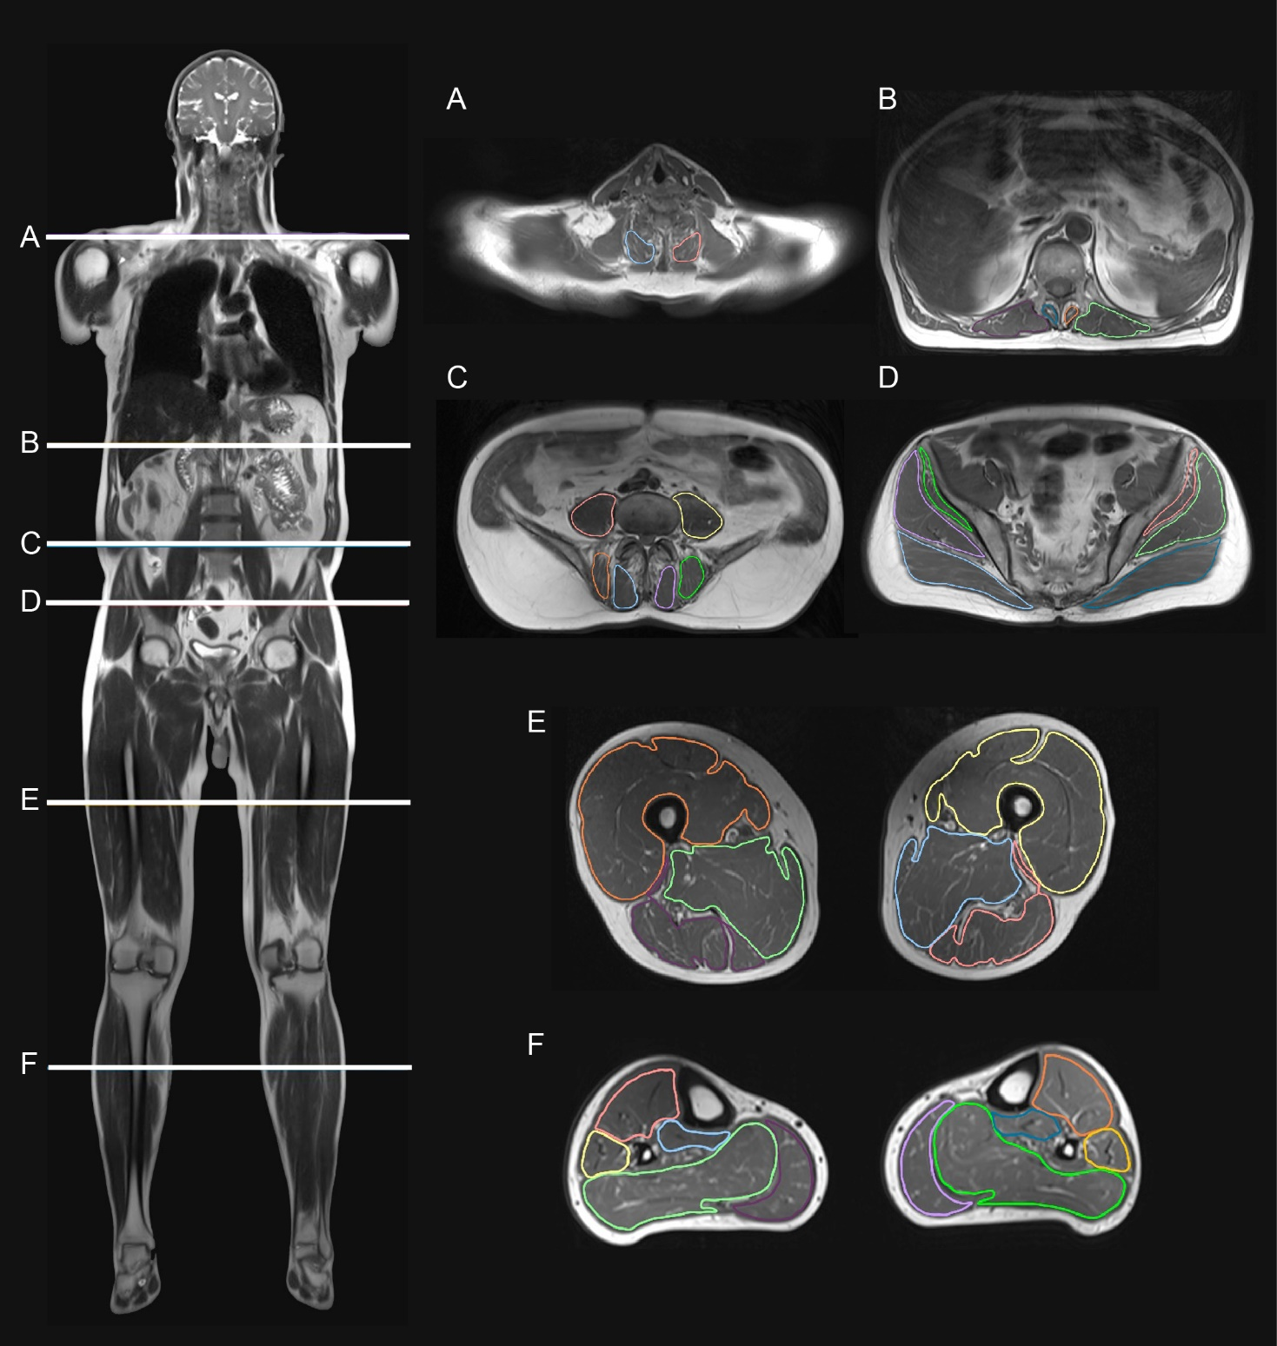

**Legend:** Magnetic resonance imaging scan positions (**A-F**) and T1-weigthed images of muscle groups outlined and investigated at each scan position. Colors on each transverse section have been applied to visualize, the individual muscles assessed at each scan position.

**Figure 2 –** Fat fractions in major muscle groups at six scan-positions

**Legend:**  Ridgeline plot showing the distribution of fat fraction values from magnetic resonance imaging in participants carrying TTNtv (pink, n=25) vs healthy matched controls (blue, n=25). Values from individual participants are represented by points inside the density function. Diamond-shaped symbols denote mean values. P-values are corrected for age, sex, and body-mass index (BMI).

**Figure 3 –** Heatmap of muscle fat fractions in participants with TTNtv vs controls

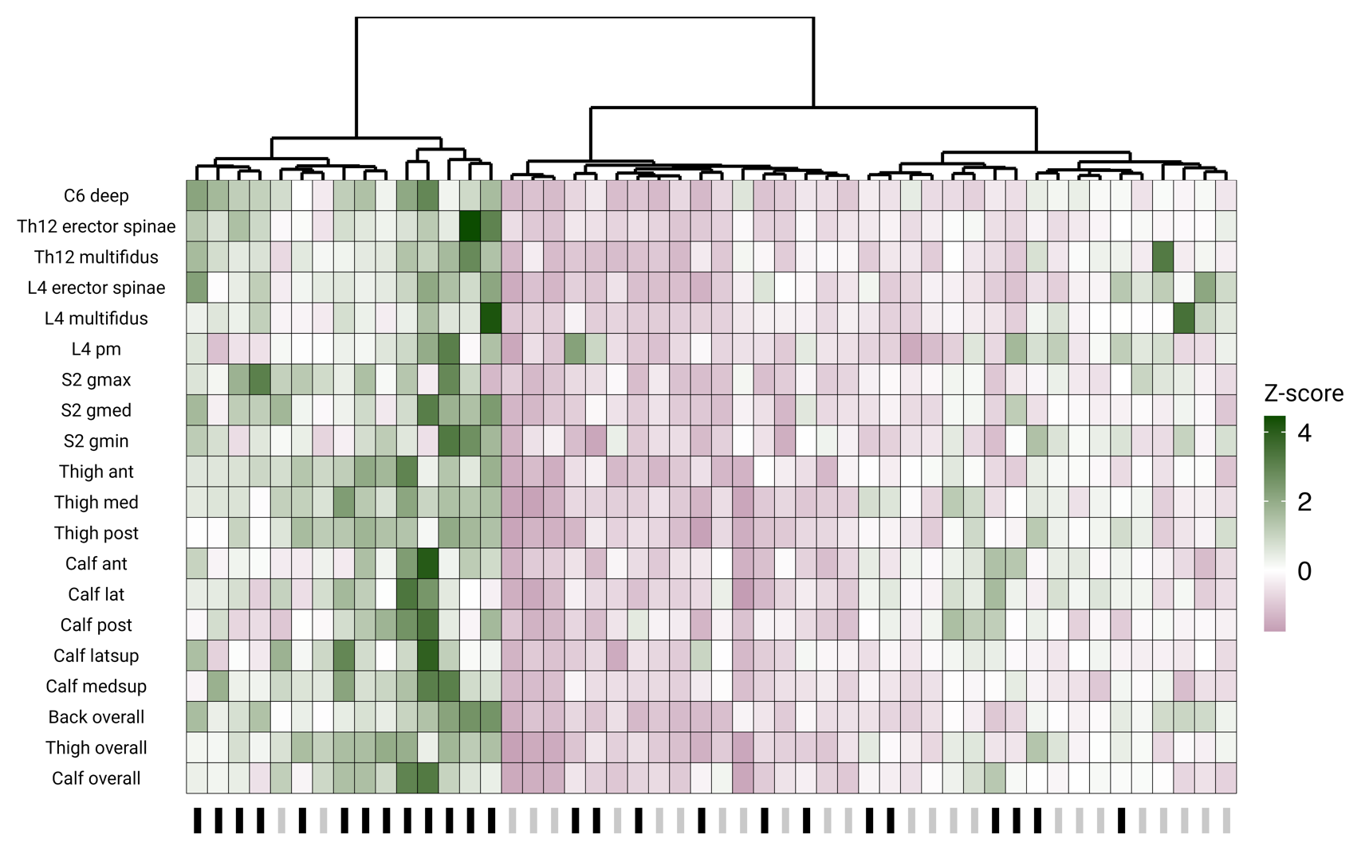

**Legend:**  Z-score-transformed muscle fat fraction in 17 individual muscles and 3 major muscle groups (y-axis) in study participants (x-axis). Healthy controls are denoted by a grey bar at the bottom while a black bar denotes a person with TTNtv. Hierarchical clustering analysis found that participants with TTNtv formed clusters. Overall, participants with TTNtv had higher fat fractions as seen by a higher luminosity of green color in this group.

**Figure 4 –** Effect of carrying a TTNtv on muscle fat fraction



**Legend:** Results from linear mixed modeling of fat fraction across all muscle groups. Effect estimates and confidence intervals are calculated by bootstrap resampling with replacement. The density function shows the distributon of point-estimates (shown as black bars) from each bootstrap, while the slab provides the point estimate (point) and the 66% (thick part) and 95% (thin part) uncertainty intervals from the probability density function.

**Figure 5 ­–** Skeletal muscle biopsies from patients with TTNtv

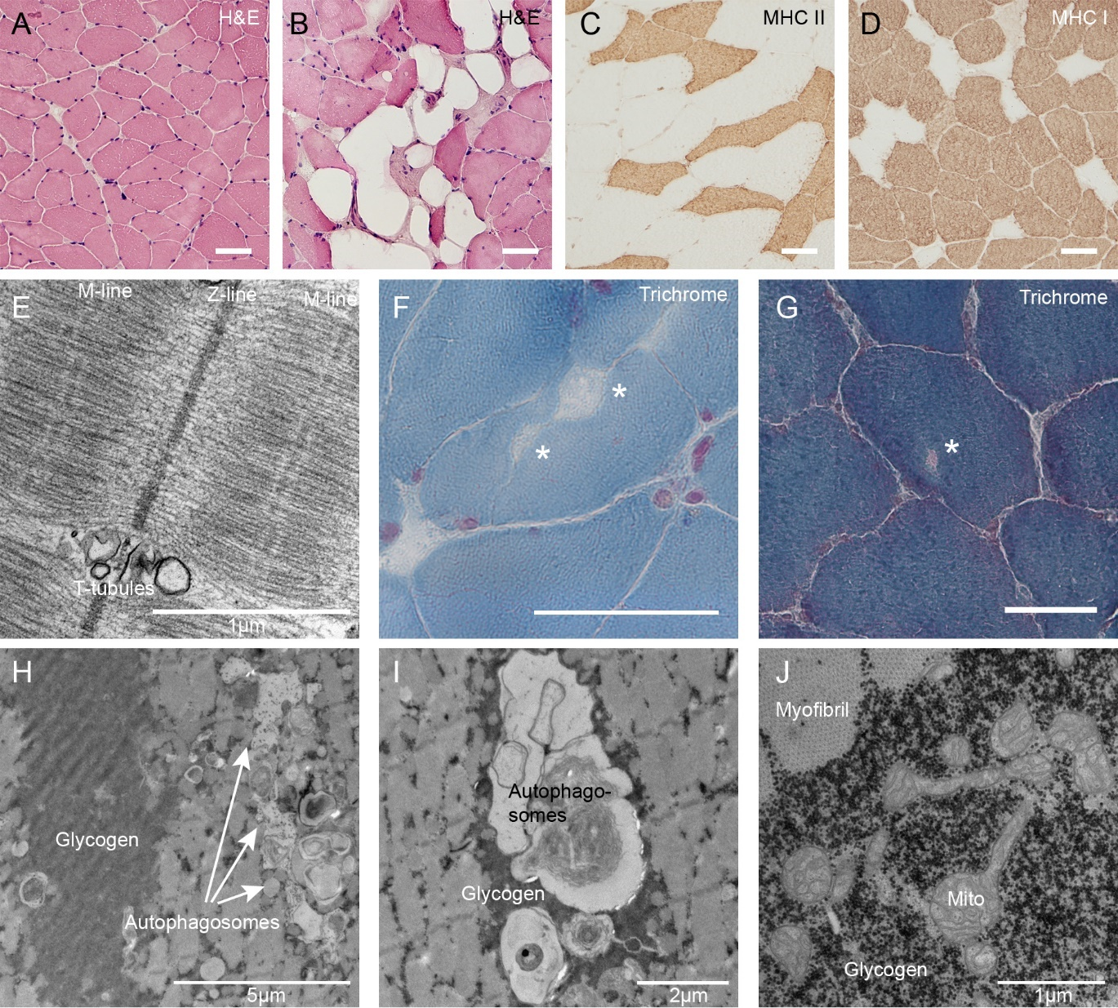

**Legend:** Histology, immunohistology and transmission electron microscopy findings in muscle biopsies from patients with TTNtv. **A.** Hematoxylin & eosin (H&E) stained section demonstrate centrally nucleated fibers, a sign of ongoing degeneration-regeneration cycles. **B.** Substantial fat replacement of muscle fibers. **C.** Myosin heavy chain type (MHC) II atrophy in one patient. **D.** Myosin heavy chain I predominance in one patient. **E.** Transmission electron microscopy (TEM) image showing parts of two sarcomeres on either side of the Z-line. While the Z-line is straight, the M-line on either side of the Z-line appears ragged and discontinuous. **F-G.** Trichrome stained sections demonstrate inclusion bodies (marked with an asterisk). **H**. TEM image demonstrating a very large accumulation of free non-lysosomal glycogen to the left and a very large group of autophagosomes. **I.** Autophagosomes engulfing organelles and surrounded by a pool of free glycogen. **J.** Part of a large accumulation of subsarcolemmal glycogen and elongated mitochondria, demonstrating affected fusion/fission dynamics. Bar in histology images is 50µm

**Figure 6 –** Correlations between muscle fat fraction and clinical factors in participants with TTNtv.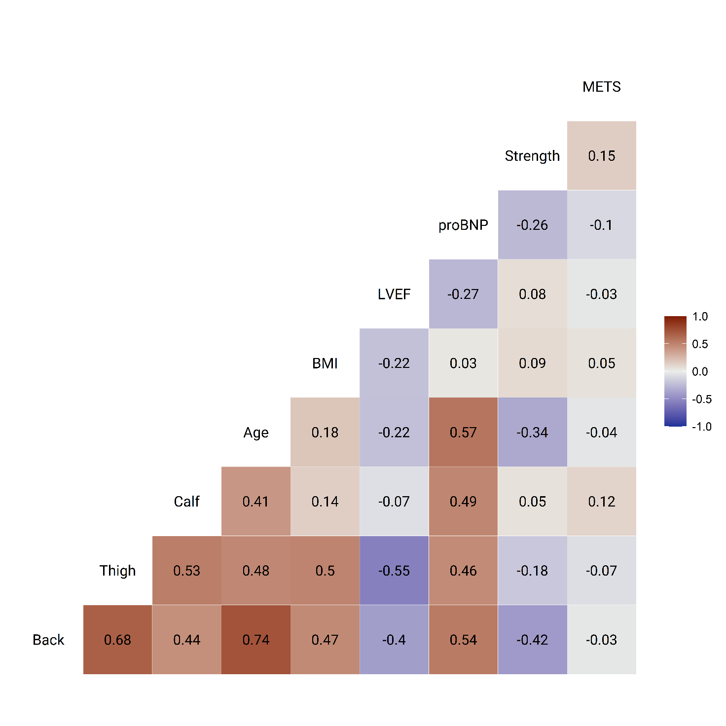**Legend:** Correlogram showing relationships between 6 clinical variables and fat fraction in three muscle groups (back, thigh and calf) in patients with TTNtv. Dark colors denote strong positive or negative correlations. The number in each tile represents the Pearson correlation coefficient. Muscle strength was defined as the mean of all investigated muscle-groups after Z-score transformation. Metabolic equivalents of task (METS) were calculated from reports in the IPAQ-score. *Abbreviations:* BMI, body-mass index; LVEF, left ventricular ejection fraction; proBNP, N-terminal prohormone of brain natriuretic peptide.

**Table 1 – Clinical characteristics of the study population**

|  |  |  |  |  |  |  |  |  |  |
| --- | --- | --- | --- | --- | --- | --- | --- | --- | --- |
| Pt | Sex | Cardiac phenotype | Age, years | Time since diagnosis, years | LVEF at time of study (%) | GLS at time of study (%) | LVEF (%) at disease onset | LVIDd-indexed, mm/m2 | Genotype (NM_001267550.1) |
| 1 | M | Negative | 30 | NA | 57 | -14.4 | NA | 23.1 | c.91716insA; p.(Asn30572LysfsTer16) |
| 2 | M | DCM/HTx | 59 | 15.6 | 47* | -6.0* | 20 | 28.2 | c.91716dupT; p.(Met30573TyrfsTer15) |
| 3 | F | Negative | 43 | NA | 61 | -22.0 | NA | 29.6 | c.102290delT; p.(Leu34097ArgfsTer27) |
| 4 | F | HNDC | 50 | 14.8 | 47 | -15.4 | 50 | 24.6 | c.62231_62237delAAACAAA; p.(Gln20744ArgfsTer10) |
| 5 | M | Negative | 31 | NA | 54 | -20.1 | NA | 29.7 | c.102290delT; p.(Leu34097ArgfsTer27) |
| 6 | M | DCM | 47 | 4.5 | 39 | -9.9 | 22.5 | 23.1 | c.90572del2Ins21; p.(Ile30191ArgfsTer23) |
| 7 | F | DCM | 53 | 1.4 | 36 | -9.3 | 50 | 32.2 | c.11952C>A; p.(Tyr3984Ter) |
| 8 | F | DCM | 53 | 22.1 | 45 | -14.4 | 30 | 27.9 | c.58117dupT; p.(Cys19373LeufsTer10) |
| 9 | M | DCM | 43 | 5.7 | 46 | -14.2 | 45 | 29.1 | c.48181G>T; p.(Glu16061Ter) |
| 10 | F | DCM | 53 | 6.8 | 40 | -11.9 | 42.5 | 27.4 | c.40626dupA; p.(Pro13543ThrfsTer13) |
| 11 | F | DCM | 49 | 0 | 42 | -10.8 | NA | 30.0 | c.47314C>T; p.(Arg15772Ter) |
| 12 | M | DCM | 51 | 6.3 | 39 | -11.1 | 40.4 | 31.3 | c.89197+2T>G; Splice-site |
| 13 | M | DCM | 25 | 3.0 | 39 | -12.1 | 47.5 | 22.8 | c.85519dupA; p.(Met28507Ter) |
| 14 | M | DCM | 34 | 13.1 | 48 | -16.4 | 10 | 27.6 | c.42088delC; p.(Gln14030LysfsTer18) |
| 15 | F | DCM | 57 | 14.0 | 40 | -13.6 | 15 | 31.4 | c.42667C>T; p.(Gln14223Ter) |
| 16 | M | Negative | 36 | NA | 50 | -16.4 | NA | 21.7 | c.85519dupA; p.(Met28507Ter) |
| 17 | M | DCM/HTx | 62 | 21.9 | 48* | NA | 10 | 22.6 | c.85519dupA; p.(Met28507Ter) |
| 18 | M | DCM/HTx | 68 | 24.4 | 58* | NA | 10 | 23.8 | c.58117dupT; p.(Cys19373LeufsTer10) |
| 19 | M | DCM | 72 | 17.4 | 45 | -14.2 | 27.5 | 32.2 | c.12271C>T; p.(Gln4091Ter) |
| 20 | F | DCM | 57 | 2.3 | 35 | -11.9 | 30 | 29.3 | c.74015delC; p.(Thr24672MetfsTer8) |
| 21 | F | DCM | 74 | 26.4 | 17 | -11.9 | 20 | 39.6 | c.48181G>T; p.(Glu16061Ter) |
| 22 | M | DCM | 27 | 2.3 | 37 | -15.2 | 7.5 | 27.8 | c.11952C>A; p.(Tyr3984Ter) |
| 23 | M | Negative | 41 | NA | 60 | NA | NA | NA | c.102290delT; p.(Leu34097ArgfsTer27) |
| 24 | F | DCM | 60 | 13.2 | 55 | -16.5 | 35 | 24.5 | c.43544dupT; p.(Phe14516IlefsTer8) |
| 25 | F | Negative | 78 | NA | 51 | -14.1 | NA | 26.8 | c.91716insA; p.(Asn30572LysfsTer16) |
| Abbreviations: DCM = dilated cardiomyopathy, F = females, HNDC = hypokinetic non-dilated cardiomyopathy, HTx = heart transplantation, GLS = global longitudinal strain, LVEF = left ventricular ejection fraction, LVIDd = left ventricular internal diameter in diastole. * denotes that these echocardiographic parameters are from transplanted hearts at the most recent cardiac examination. | | | | | | | | | |